

Faculty of Computers and Artificial Intelligence

Computer Science Department

2021/2022

**CS 395 Selected Topics in CS-1**

**Research Project**

Report Submitted for Fulfillment of the Requirements and ILO’s for Selected Topics in CS-1 course for Fall 2021

Team No. 3

|  |  |  |  |
| --- | --- | --- | --- |
|  | ID | Name | Grade |
|  | 201900160 | الاء شريف فتحى محمد مصطفى |  |
|  | 201900148 | اسماء سعد عبد العزيز محمد عطية |  |
|  | 201900106 | احمد ناصر حسين محمد |  |
|  | 201900119 | اسامه السيد يوسف ابوالعلا |  |
|  | 201900225 | بسمله محمود محمد |  |
|  | 201900378 | شيماء محمد احمد فؤاد محمد القصبجى |  |
|  | 201900173 | امنية جاد حسني جاد |  |

Delivered to:

**Dr. Wessam El-Behaidy**

**Eng. Islam Gamal**

**Eng. Muhammed Kamal**

I. NUMERICAL DATASET

1. Project Introduction

* 1. **Dataset Name**

(What is the dataset used?)

Hr Analytics Job Prediction

* 1. **Number of classes and their labels**

(Specify number of classes and their labels.)

2 classes, [‘Stayed’, ‘Left’]

* 1. **Dataset Samples Numbers**

(The total number of samples in dataset)

14999 samples

* 1. **Training, Validation and Testing**

(The number of samples used in training, validation and testing.)

9999 Training, 1200 Validation, 3000 Testing

1. Implementation Details
   * 1. **Extracted Features**

(How many features were extracted, their names, the dimension of resulted features)

17 features

Names = ['satisfaction_level', 'last_evaluation', 'number_project',

'average_montly_hours', 'time_spend_company', 'Work_accident', 'salary', 'Department_IT', 'Department_accounting', 'Department_hr', 'promotion_last_5years', 'Department_management', 'Department_marketing','Department_product_mng', 'Department_sales', 'Department_support', 'Department_technical']

Dimension = (17,1)

* + 1. **Cross-validation**

(Is cross-validation is used in any of implemented models? If yes, specify the number of fold and ratio of training/validation)

We didn’t use cross-validation

* + 1. **Artificial Neural Network (ANN)**
* **Hyper-parameters**

(Specify all the hyper-parameters (initial learning rate, optimizer, regularization, batch size, no. of epochs…) with their specified value in implementation)

Optimizer = Adam, initial learning rate = 0.001, batch size = 32

No. of epochs = 500

* + 1. **Support Vector Machine** **(SVM)**
* **Hyper-parameters**

(Specify all the hyper-parameters (optimizer, regularization, …) with their specified value in implementation)

Kernel = rbf, C = 1000

1. Models Results

**For each model you should show all these results for your model on testing data** (loss curve, accuracy, confusion matrix, ROC curve)

* 1. **ANN Results**

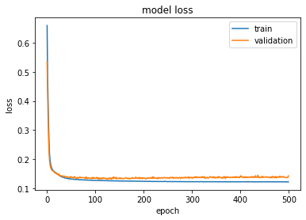

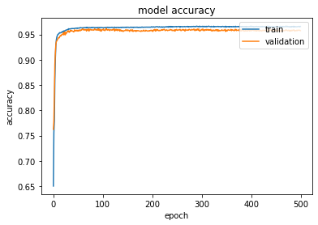

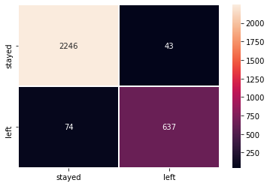

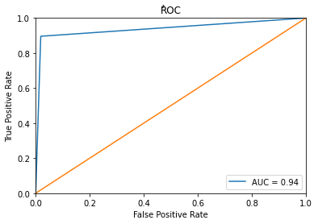

Test: Accuracy = 96.1%, Precision = 95.2%

* 1. **SVM Results**

Test: Accuracy = 97.1%, Precision = 95.9%

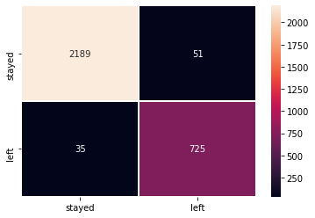

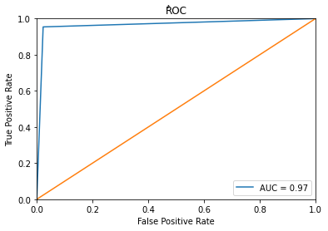

II. IMAGE DATASET

1. Project Introduction

* 1. **Dataset Name**

(What is the dataset used?)

Female and male eyes.

* 1. **Number of classes and their labels**

(Specify number of classes and their labels.)

2 classes, [‘femaleeyes’, ‘maleeyes’]

* 1. **Dataset Images Numbers and size**

(The total number of images in dataset and the size of each.)

11525 images, (32,32)

* 1. **Training, Validation and Testing**

(The number of images used in training, validation and testing.)

8298 Training, 921 Validation, 2306 Testing

2. Implementation Details

* + 1. **Extracted Features**

(How many features were extracted, their names, the dimension of resulted features)

1024 features, (1024,1)

* + 1. **Cross-validation**

(Is cross-validation is used in any of implemented models? If yes, specify the number of fold and ratio of training/validation)

We didn’t use any cross-validation

* + 1. **Artificial Neural Network (ANN)**
* **Hyper-parameters**

(Specify all the hyper-parameters (initial learning rate, optimizer, regularization, batch size, no. of epochs…) with their specified value in implementation)

Optimizer = Adam, initial learning rate = 0.00001, batch size = 64

No. of epochs = 150

* + 1. **Support Vector Machine** **(SVM)**
* **Hyper-parameters**

(Specify all the hyper-parameters (optimizer, regularization, …) with their specified value in implementation)

Kernel = poly, C = 1

3. Models Results

**For each model you should show all these results for your model on testing data** (loss curve, accuracy, confusion matrix, ROC curve)

* 1. **ANN Results**

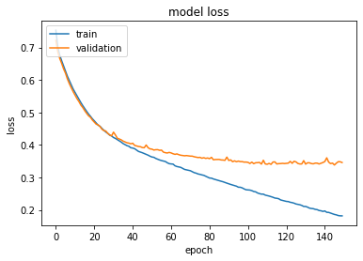

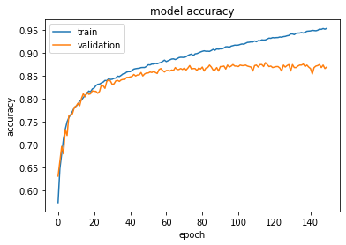

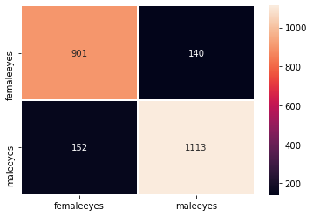

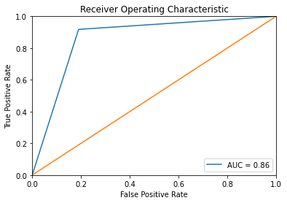

Test: Accuracy = 86.8%, Precision = 87%

* 1. **SVM Results**

Test: Accuracy = 87.2%, Precision = 87.3%

